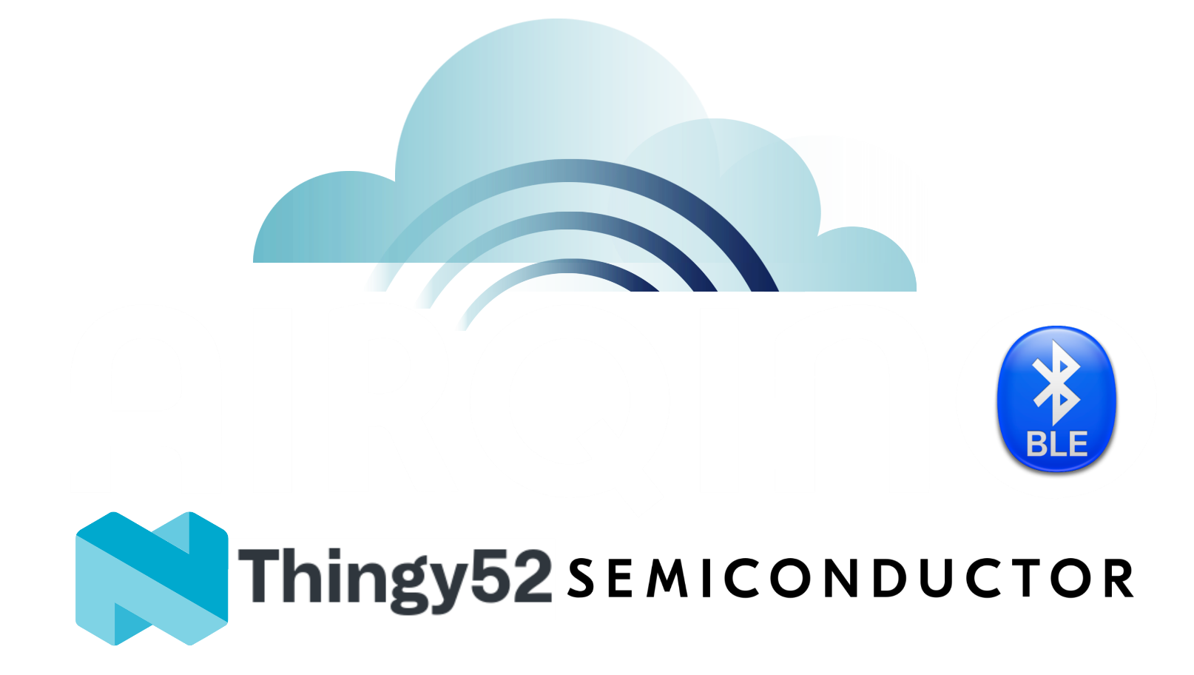

Air Quality Innovation

PROJECT PROPOSAL

Marco C, gABrIEL R, Niklas r

2021

Contents

IoT Proposal 2

Problem Statement 2

Air Quality Values per Zone 2

Division of work 2

Context Diagrams 3

Network Device Location Map Zone R10 3

Network Topology 3

Conclusion 4

Implementation 4

Learning Outcomes 4

Example Data 4

Data Proposal 5

Problem Statement 5

Dashboard Wireframe 5

Business Use case 5

Chart Wire frames 6

Heatmap 6

Timeseries 7

Augmented Reality 7

Division of work 7

Conclusion Implementation 7

Learning Outcomes 7

Bottlenecks 8

Power 8

No access to Internet 8

Expansion Possibilities 8

IoT 8

Data 8

Air Quality Innovation Proposal

# IoT Proposal

## Problem Statement

This past year has been filled with restrictions and dangers due to the Pandemic. It is not safe to have many students grouped up in small spaces. With this project we aim to measure the quality of the air, PPM / VOC values, and display the data live using a Bluetooth Low Energy network.

## Air Quality Values per Zone

The idea of this project is to calculate the carbon dioxide levels in the floor of the school building. We will be using the ESP32 as a client and the Nordic Thingy:52, as well as the Raspberry Pi, as a Server. The idea was to collect as many values as possible and log them. Our proposal will be divided in steps:

1. Obtain the PPM values using an ESP from the Thingy:52
2. Obtain the PPM values using an ESP from multiple Thingy:52’s
3. Write the obtained values to the Raspberry Pi
4. Log the values from the Raspberry Pi to a database’
5. Visualize the values from the Raspberry Pi using D3js or Grafana

We want to use BLE in this project since we got acquainted with the GATT Server architecture. The Thingy:52 has an environmental service with multiple characteristics; each characteristic provides a sensor value that can describe the environment (Example: Temp, Hum, CO2…).

## Division of work

Marco C – [ESP32 range extender](https://github.com/m1a2x32/AIRQUINO)

Gabriel R – RPI python scripts

Niklas R – RPI bash scripts

## Context Diagrams

### Network Device Location Map Zone R10

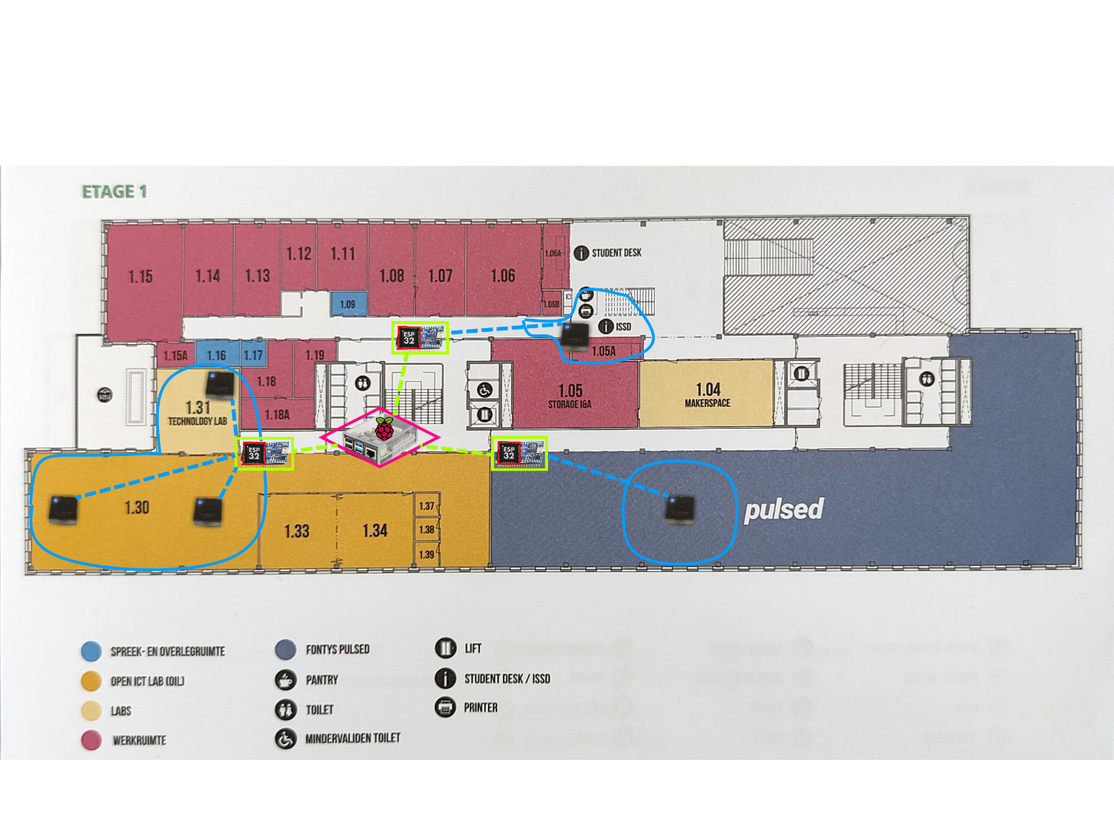

### Network Topology

We have a raspberry Pi logging the average of the carbon dioxide levels collected (PPM) every 15 seconds. We use the ‘watch -n 16 script’ command to logs in a .csv file, this command allows us to run a certain script every x amount of second. We have created a script to log an average of all the values connected. We have chosen 15 seconds as an interval since it was an approximate walking distance between each sensor area.

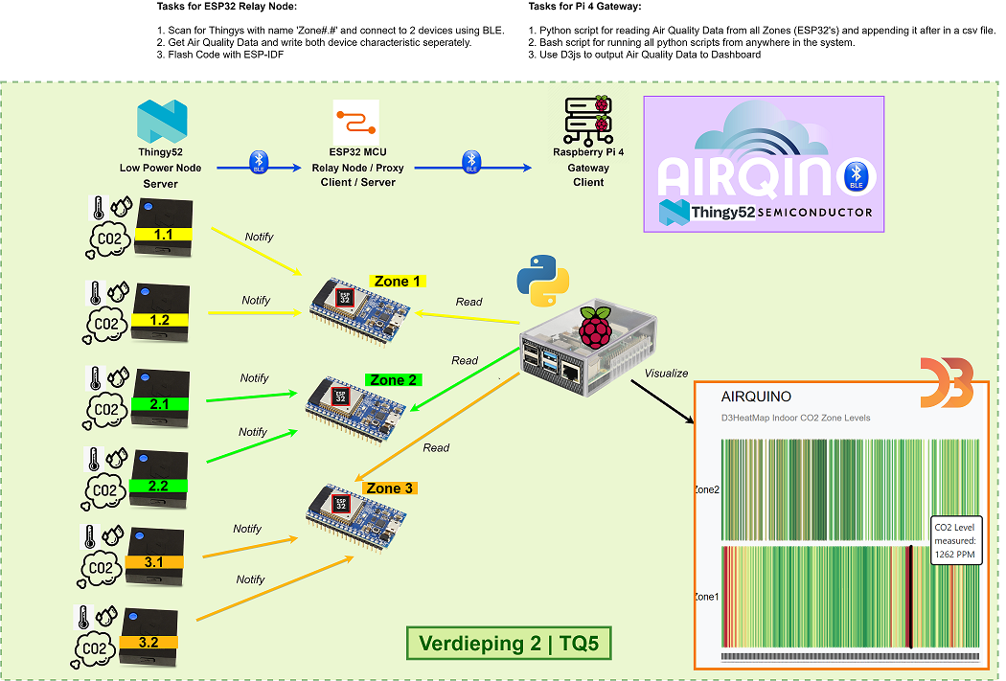

## Conclusion

### Implementation

After setting up the network in school, we will now collect data for multiple days to be able to visualize the data. The ESPs manage to advertise the data collected from the Thingy:52 correctly, and the Raspberry PI, acting as a gateway, is logging the data correctly. The next step would be to setup the graph to use live data but that will be completed in the Data / HMI Module mini project.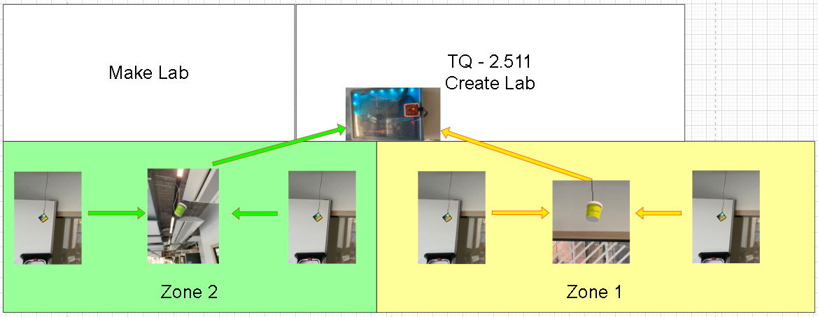

### Learning Outcomes

This project has expanded our knowledge in configuring and handling BLE GATT Servers. An extensive amount of research had to be done to fully understand how to setup the entire network, starting from extending the range of the Thingy:52 (with esp32), to creating the logging server to collect data from all range extenders.

### Text Description automatically generatedExample Data

This data format will help us differentiate the zone where the device is, and we can display it with a corresponding color. We will have an interactive dashboard; it will be explained in the Data Proposal.

# Data Proposal

## Problem Statement

Having the data can be useful but if you cannot visualize it, it might not be easy to understand to the public. Considering the strawberry field project, we have thought to propose a visual representation of the CO2 using a heat map.

For these data visualizations we will use the Python framework, the library dash will be used for the interactive dashboard. We will explore both options and **if time is not an issue**, we will develop the project a little further and implement augmented reality. What we want to do with augmented reality is to define the levels of carbon dioxide by brightness (lighter = safe, darker = less safe).

## A picture containing timeline Description automatically generatedDashboard Wireframe

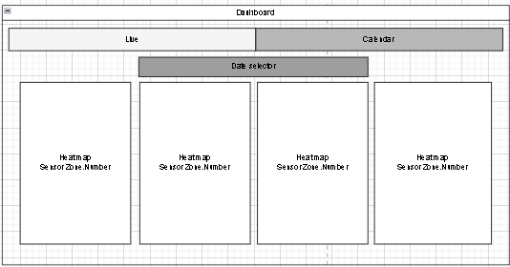

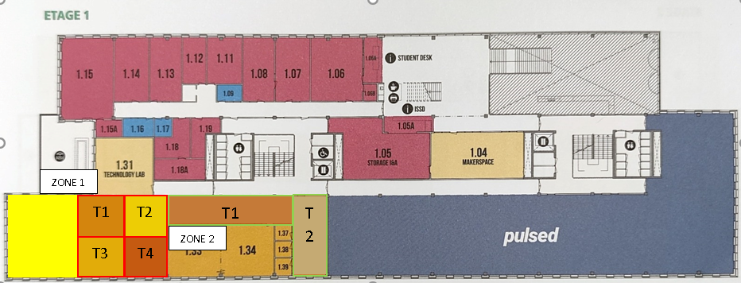

## Business Use case

Our goal with this project is to track movement around the school by measuring the carbon dioxide levels in zones divided around the school. Our testing occurs in the Oil 1.30, this area is our day-to-day study area in R10 and is always filled with students. We can collect good amounts of data in this area to implement the “movement tracker”.

* The dashboard should show crowd movement around the covered areas
* The dashboard should show data from the logs on previous dates

## Chart Wire frames

### Heatmap

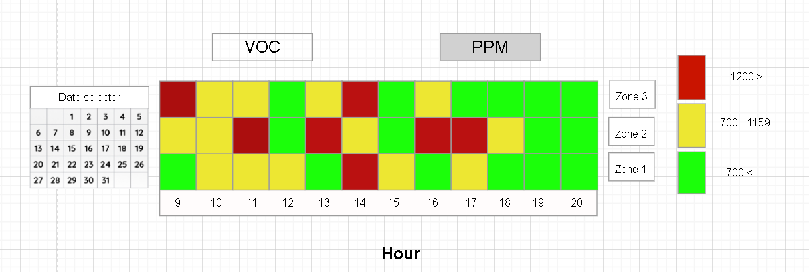One of the charts we want to use to display the data is going to be a heat map. This heat map will be used to represent the levels of the value selected on the top, VOC(Volatile Organic Compounds) or PPM(CO2). The right side will serve as a legend to indicate whether the levels are safe or not. The redder it gets, the higher the levels being read. This chart will help us compare the levels from different zones and compare them.

On the other hand, if we would like to see the live data according to the heatmaps color code, we will add a map of the floor and color the zone according to the corresponding sensor values. This type of data is useful because it could give us insight on the amount of people gathered per area.

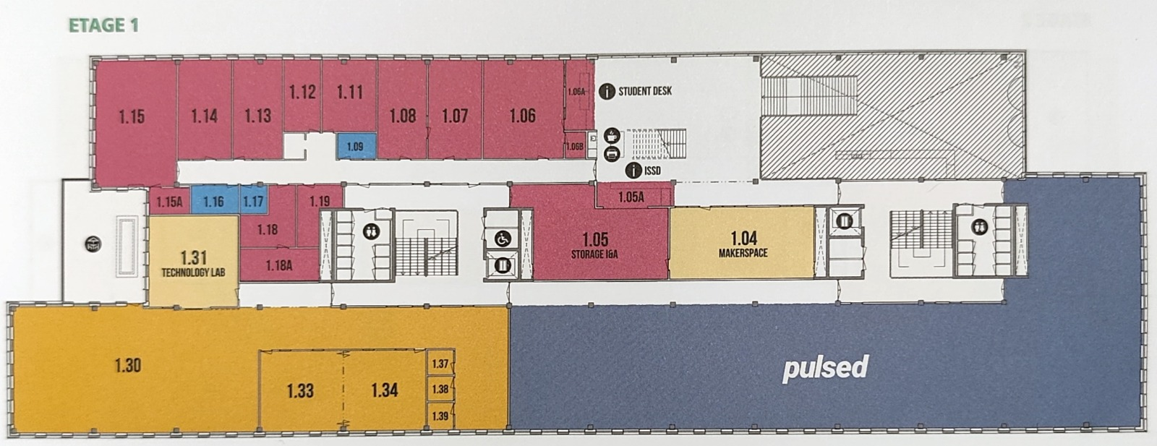

T4

ZONE 2

T1

T2

T1

T2

T3

ZONE 1

### Chart, line chart Description automatically generatedTimeseries

This chart will be used to compare the values real time. We can have a more in depth look of what is happening around the building. The difference between this chart and the previous, is that the previous one is used for statistics vs this one is used to visualize the data. The timeseries chart will be less accurate as it could spike the levels if someone passes by or someone tampers with the sensor.

## Augmented Reality

<Missing info>

## Division of work

Marco C – Dashboard

Gabriel R – Augmented Reality

### Conclusion Implementation

<Missing pictures of implementation>

### Learning Outcomes

This project has given us the chance to broaden our knowledge in developing dashboard and visualizing data. We have created a dashboard that can give some insight in what is happening around the school and what has happened around the school. Even though there are only two zones, setting up the structure can facilitate the expansion of the entire floor.

<Missing Learning outcomes of AR>

# Bottlenecks

## Power

We noticed that the battery of the Sensor (Thingy:52) lasted 1 day when a client is subscribed to its notifications. We got some cables from ISSD and plugged it directly to the wall.

## No access to Internet

Having the setup in the school forces us to run everything locally, since the Wi-Fi does not allow any wired / wireless connections. We tested the wired connection by plugging in the Server in an access point in R10 and it was giving us a network with no internet access. This limits our testing possibilities since we have to come to the school whenever we want to collect the new CSV or check if the server is still running.

# Expansion Possibilities

This project could be treated as an on-going project and could be improved by adding functionalities. This could be an interesting project to pick up for future Smart industry students. This semester was filled with unknowns and as a result, time constraints.

## IoT

Possible expansion possibilities are to create a meshed network with the ESP32’s and avoid centralizing the Raspberry Pi to be in range of all ESP’s. The code could be improved to be “Plug and Play” and it could be expanded by adding a camera and counting how many people are in the area with tensor flow (or other libraries). This could improve the accuracy of the “danger meter” as it could correlate the air quality with number of people in the area.

## Data

To being with, if it is possible to connect the server to the internet a connection to a database could allow the live data. Since we are doing everything locally, the chart will update every minute. Moreover, we could do something about the large levels of carbon dioxide measured. If the case was that the levels are extremely high, we could set some plants in the area or activate a machine that could handle the high levels.